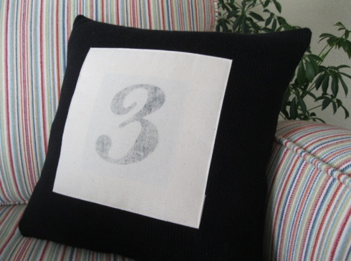
Printing Numbers onto Fabric at Home
{it’s easy}
In this tutorial we will show you how make a black print onto fabric.
Except for a quick trip to the local copy center, you can do all of the steps easily at home. The print on the fabric comes out vintage looking and is permanent.

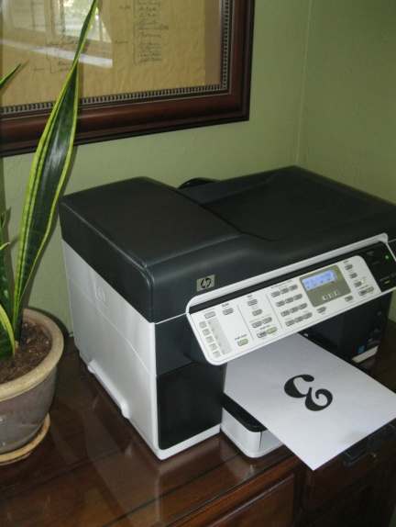
Materials:
- Copy of number
- Fabric
- Straight Pins
- CitraSolve (concentrated)
- Paintbrush
- Big Spoon
- Iron

Print your number on your printer at home.
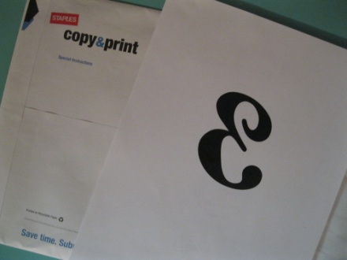
Take it with you to your local copy shop and have them copy it in mirror-image using a laser copier. This step is really important: the fabric print will not work out if the print is NOT laser ink.
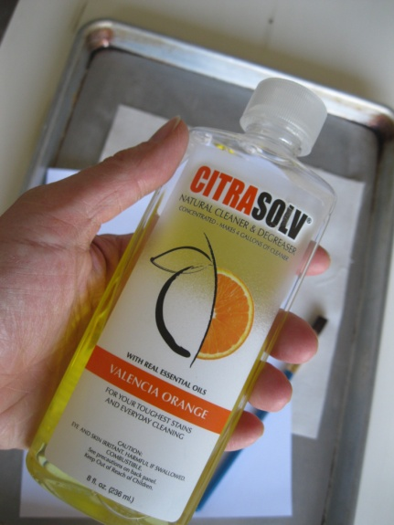
Another important aspect is using the right medium.
CitraSolve is a natural cleaner and degreaser. Make sure to buy the concentrated version of this product. It has a strong but pleasant smell, and because it is a natural product you will not have to worry about dangerous toxins as you make your print. That’s always nice.
(In my city CitraSolve is available at Fred Meyer in the health section.)
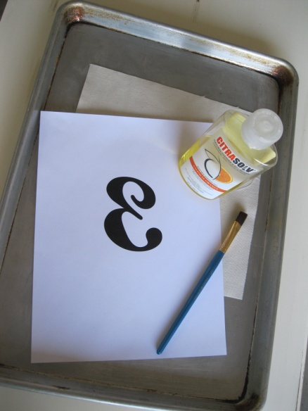
You may use any kind of fabric you like.
My fabric of choice is unbleached cotton canvas.
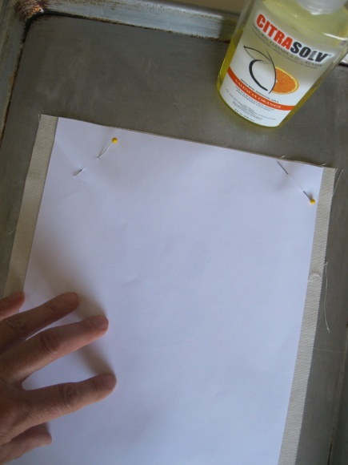
Place your fabric on a hard surface (I like to use an old cookie sheet that I have).
Position the mirror-image-laser-jet-copy on top of the fabric, face down. Pin in place at the top.
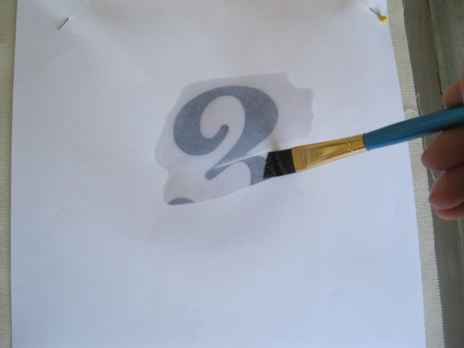
Dip your paintbrush in the bottle of CitraSolve, and “paint” the medium onto the back of the copied paper. The image will start to appear, no longer in mirror image….
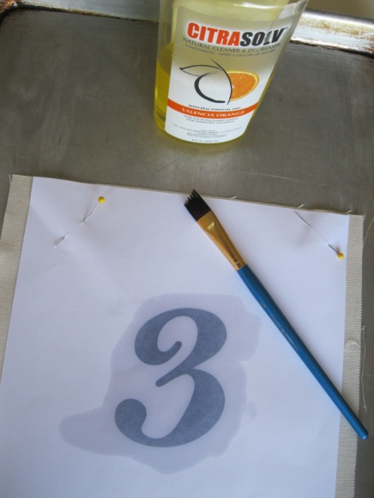
Make sure to cover the whole image. No need to be frugal, this bottle will last a LONG time….
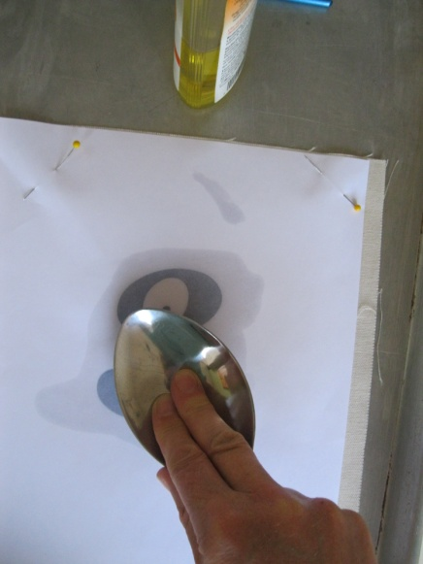
Using the back of the spoon, rub hard onto the image. Push and keep rubbing and rubbing.
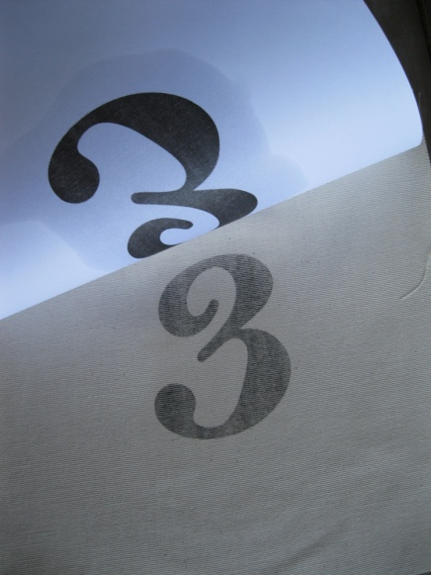
Yes, go ahead and peak: it’s OK. Lift up the paper to see how the transfer is coming along if you’d like; the pins will keep the paper in the correct position. Rub until your image is to your liking.
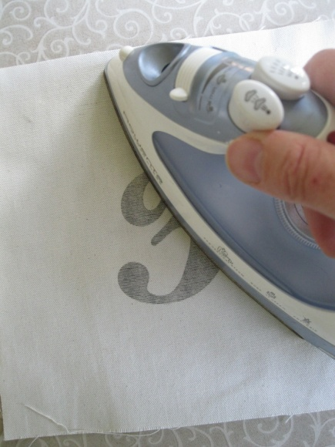
Remove the paper and discard. Next heat-set the printed image onto the fabric with a hot iron. Move the iron slowly back and forth for 10-15 seconds.
Voilá!
Your print is done…! Enjoy…. :-)

